Colud DevOps ( Terraform )
======================
Why infrastructure as code?
In a manual approach, you will start with provisioning a server from cloud. Then go ahead and install some software on it, maybe something like Java, Tomcat, Python etc manually to run your application. In case of microservices you may have several instances of microservices of different technologies. For that you may need to install different software to run your application. So manual approach is very, very slow and difficult to implement.
To overcome from this, we can go for infrastructure as code. In infrastructure as code, We can treat infrastructure the same way as you treat your application code.
So infrastructure as code is nothing but create or setup the infrastructure from code. Using this we can easily provision a server and customize the software on this server without any error.
For that we can use Terraform or Aws CloudFormation.
Using tools like Terraform you can create a number of resources in the cloud, like virtual servers, load balancers, databases, networking configuration etc.

Why/what is Configuration management?
Configuration management is all about managing the software which you want to install on your servers. The most popular configuration management tools are Ansible, Chef, and Puppet.

What is the extension of terraform files? How to check version terraform?
The extension of terraform file is .tf
terraform --version will show the version of terraform.

How to create Terraform project in your laptop to write Terraform code in visual studio?
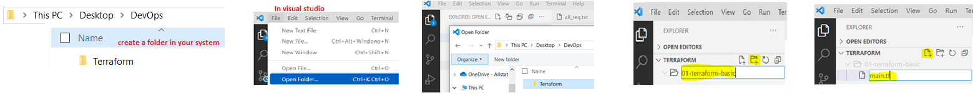
cd /DevOps/Terraform/01-terraform-basic
create a file vi main.tf
provider “aws”{ ---------------- provider use to download cloud specific APIs when we
region = “us-east-1” execute terraform init
version = “~> 2.46”
}
terraform init ---------------------- from the out put we will get the version of cloud api
and we will use it in main.tf
Now go to /DevOps/Terraform/01-terraform-basic path you will get a hidden folder “ .terraform”
Inside the folder you will see a plugin folder and inside plugin folder you will see a file terraform provider.

When you will be using Terraform version 0.13 or greater the main.tf is as below.
terraform{
required_providers{
aws = {
source = “hashicorp/aws”
version = “~>3.0”
}
}
}
provider “aws”{
region = “us-east-1”
}
How to create IAM user in AWS? How to create user access key and secret key in AWS?
AWS console ---- IAM ---- add user ---- provide user name , aws access type --- attach policy ---- provide tag ---- click on create user
Now you will get the user name, access key, secret access key for that user and you can download the csv fie and save it.

How to add the access key and secrete key and secret key in Terraform?
To add access key and secret key in terraform we need to use any of the below process
Static credentials ---------------------------- not advisable
Environment variables
Share credential file
EC2 role

How to create Environment variables for access key and secrete key and use it in Terraform?
export AWS_ACCESS_KEY_ID=AKHMNEFUHWOBVER
export AWS_SECRET_KEY_ID=NHTVIKHKGOLERMPLERSDRTWITLJLWPLDSA

terraform{
required_providers{
aws = {
source = “hashicorp/aws”
version = “~>3.0”
}
}
}
provider “aws”{
region = “us-east-1”
access_key = “AWS_ACCESS_KEY_ID”
secret_key = “AWS_SECRET_KEY_ID”
}

How to create S3 bucket using terraform?
provider “aws”{
region = “us-east-1”
version = “~> 2.46”
}

# plan - execute

resource “aws_s3_bucket” “my_terraform_s3_bucket”{
bucket = “my-s3-bucket-suman-500”
}

Now execute terraform plan -------------- it will tale us what will happen if the code will execute
Once you are ok with the out put of terraform plan , we can run terraform apply to create the resource.

Now terraform apply --------- it will create the resource ( s3 bucket in aws ).

If you check the folder structure , we will see a file terraform.tfstate under main.tf file.
The file is used to keep track of the state present in terraform.

Note whenever you execute Terraform apply, the result of the execution is stored in something called a Terraform.tfstate files.

What is state in terraform? What is tfstate file?
whenever you execute Terraform apply, the result of the execution is stored in something called a Terraform.tfstate files.

What are the states in terraform? What is Desired state , Known state , Actual state?
There is Desired state , Known state , Actual state.
Desired state what we required after executing terraform code.
Known state the state present in Terraform.state file.
Actual state The actual state is whatever is the state of the bucket in AWS.

Note Whenever you are doing Terraform apply, what Terraform does is it compares the desired state versus actual, it finds out the differences and applies them to make sure that the desired and the actual state are the same.

What is refreshing state?
The refreshing state is about the change going to happen in AWS from terraform.
Let’s say we will change the bucket name “ my-s3-bucket-suman-700”
When we execute terraform apply

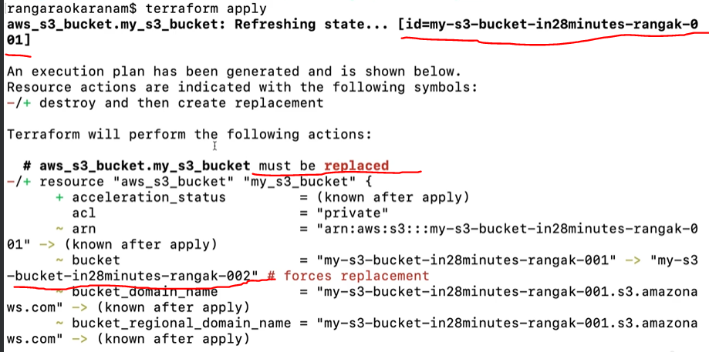

How to enable versioning for S3 bucket in terraform?
provider “aws”{
region = “us-east-1”
version = “~> 2.46”
}

# plan - execute

resource “aws_s3_bucket” “my_terraform_s3_bucket”{
bucket = “my-s3-bucket-suman-500”
versioning {
enabled = true
}
}
terraform apply ---> now Terraform compares the desired state versus actual, it finds out the differences and applies them to make sure that the desired and the actual state are the same.

What is terraform console?
terraform console use to inspect your state data without modifying and allows you to interactively evaluate Terraform expressions before using them in your configuration. To exit from terraform console hit Ctrl-C or Ctrl-D, or type exit.

When we execute terraform console we will get the below prompt where we can execute
>

How to check/refer to a resource in terraform console?
terraform console
> type of the object dot the name of the object dot attribute

Example
terraform console
> aws_s3_bucket. my_terraform_s3_bucket ---------- you can see all the details of that S3 bucket like domain name , ID of the bucket , which region we are creating it etc

> aws_s3_bucket. my_terraform_s3_bucket.versioning ------- here we can see the versioning attributes value
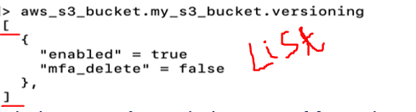
> aws_s3_bucket. my_terraform_s3_bucket.versioning[0] ------- here we can see the versioning attributes value
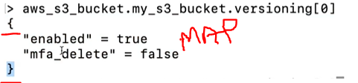

How do I access information from the map?
> aws_s3_bucket. my_terraform_s3_bucket.versioning[0].enabled

How to access the map data in terraform code?
provider “aws”{
region = “us-east-1”
version = “~> 2.46”
}

# plan - execute

resource “aws_s3_bucket” “my_terraform_s3_bucket”{
bucket = “my-s3-bucket-suman-500”
versioning {
enabled = true
}
}
Output “my_terraform_s3_bucket_complete_detail”{
aws_s3_bucket. my_terraform_s3_bucket ------------> it will give the complete detail of bucket
}
Output “my_terraform_s3_bucket_versioning”{ ----------> it give the version status using map
aws_s3_bucket. my_terraform_s3_bucket.versioning[0].enabled
}

terraform apply -refresh=false when we execute this terraform skip the default behavior of refreshing the Terraform state we will get only the output.

How to create IAM user using Terraform?
provider “aws”{
region = “us-east-1”
version = “~> 2.46”
}

# plan - execute

resource “aws_s3_bucket” “my_terraform_s3_bucket”{
bucket = “my-s3-bucket-suman-500”
versioning {
enabled = true
}
}

resource “aws_iam_user” “my_tf_iam_user”{
name = “my_tf_user_suman”
}

Let’s create a plan and save it in a file
terraform plan -out iam.tfplan ----------> it will save the plan in iam.tfplan file
if the plan looks fine then you can apply the plan file or you can use terraform apply command.

Let’s apply the terraform plan file
terraform apply “iam.tfplan”

Let’s add the code to get the iam output from terraform.

provider “aws”{
region = “us-east-1”
version = “~> 2.46”
}

# plan - execute

resource “aws_s3_bucket” “my_terraform_s3_bucket”{
bucket = “my-s3-bucket-suman-500”
versioning {
enabled = true
}
}

resource “aws_iam_user” “my_tf_iam_user”{
name = “my_tf_user_suman”
}

Output “my_tf_iam_user_complete_data”{
aws_iam_user. my_tf_iam_user ----------------> we will get arn for iam
aws_iam_user. my_tf_iam_user.arn -------------> arn value for iam
}

Now execute terraform apply -refresh=false

How to update iam user from terraform?
terraform apply -target=aws_iam_user. my_tf_iam_user
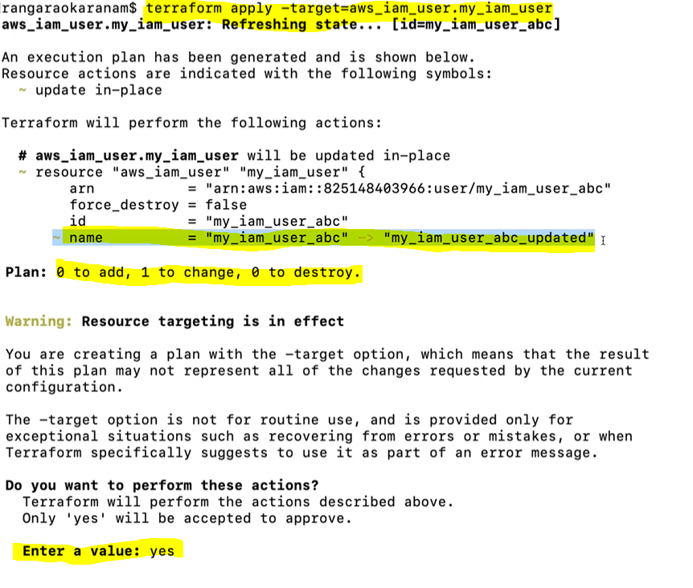
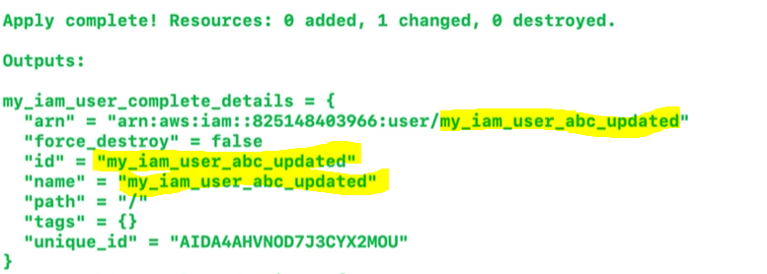

What is the use of terraform.tfstate file?
The known state contains a mapping from the Terraform name of the resourceto the AWS identifier for specific resource. And when you execute a Terraform apply, Terraform would get the AWS identifier using the Terraform identifier and then it would refresh this state from the actual state.
If the terraform.tfstate does not exist then terraform not able to identify the known state. then Terraform thinks there is nothing existing and it'll try and create everything again.

How to prevent the tfstate file to commit to git repo?
Add *.tfstate , *.tfstate.backup , .terraform in .gitignore file to prevent the terraform configuration details to commit to git repo.

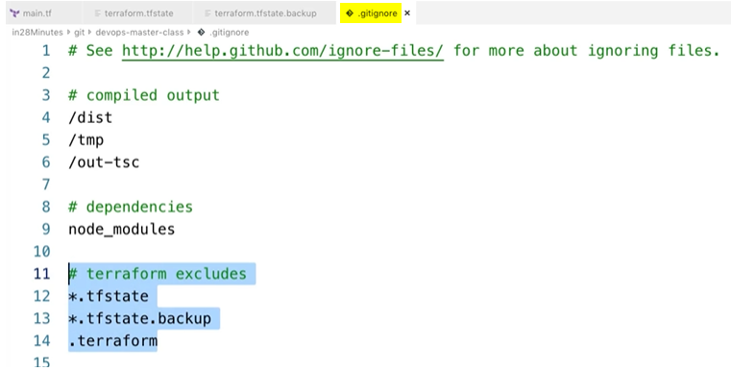

What is terraform destroy?
The terraform destroy will drop all the resources we have created.

How to run a specific tf file from multiple tf file?

How to run multiple tf file in a sequence?

How to create multiple IAM user from terraform?
Vi main.tf

Provider “aws”{
Region = “us-east-1”
Version = “~>2.46”
}
Resource “aws-iam-user” “my-tf-iam-users”{
Count = 2
Name = “my-tf-iam-users-${count.index}”
}
Now we can use terraform apply to create the multiple IAM users.

How do you validate a terraform file locally? / what is terraform validate?
terraform validate command is used to validate the syntax of the configuration files.
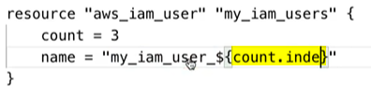
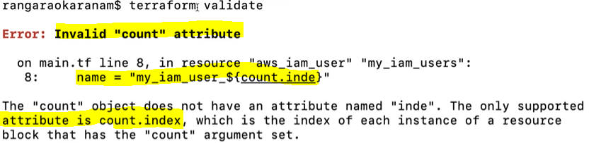

What is terraform FMT?
terraform fmt will say to format the code correctly with proper indentation. And show the incorrect format file.

What is Terraform show?
Terraform show provides human readable output on the current state which is present in the state file.
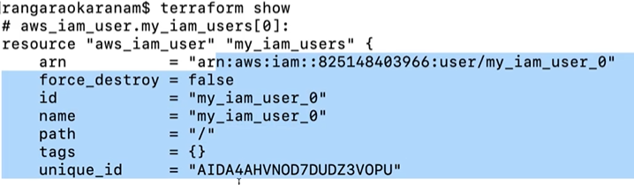
How to declare a variable and how to access it in terraform?
Vi main.tf

Variable “iam_user_name_prefix”{ ------------ declare the variable iam_user_name_prefix
Default = “my-tf-iam-users”
}

Provider “aws”{
Region = “us-east-1”
Version = “~>2.46”
}
Resource “aws-iam-user” “my-tf-iam-users”{
Count = 2
Name = “${iam_user_name_prefix}_${count.index}” -------- access the variable
}
What are the type of variables in terraform?
We can declare number , bool, list, map, set, any , object, tuple, string types of variables.

Variable “my-tf-var”{
type = string
default = “my_tf_prefix” ----------------> when we will use ‘my-tf-var’ this value will pick
}

If we will not provide any value and use the variable ‘my-tf-var’, then it will ask to enter the value.
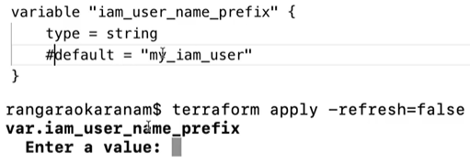
What is the Variable priority in terraform?
If we will use the same variable in all the place then the priority will be as below.
Command line, variable file , environment variable , variable in the code.

How to use a variable from command line in terraform?
Terraform plan -refresh=false -var=”my_tf_iam_user=value_from_command_line”

How to overwrite terraform variable file above command line variable?
terraform apply -var-file=”some-file-name.tfvars”

How to use list variable in terraform?
Variable “names”{
Default = [“suman”, “uma” , “tom”]
}
Provider “aws”{
Region = “us-east-1”
Version = “~>2.46”
}
Resource “aws_iam_user” “my_iam_users”{
Count length(var.names)
name = var.names[count.index]
}

Now execute terraform apply
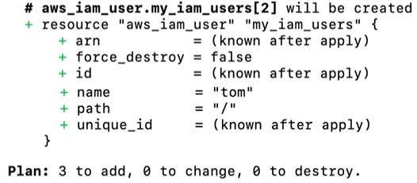
How to reverse list in terraform?
Reverse(var.names)
How to distinct value from the list in terraform?
Distinct(var.names)
How to get the length of the list variable in terraform?
Length(var.names)
How to get value of the list in terraform console?
Var.names
How to get the index value from a list in terraform console?
Var.names[0]
How to get the unique value from the list in terraform console?
Toset(var.names)
How to add a value to the list variable in terraform?
Concat(var.names, [“the_new_value”]) ------- Means you can concat two lists
How to check the value is present in the list or not in terraform?
Contains(var.names, “ravi”) ------------ result will be true or false
How to sort a list in terraform?
Sort(var.names)
How to use collections are range of in terraform?
Range(10) ------- output will be from 0 to 9
Range(1,12) ------- output will be from 1 to 11
Range(1,12,2) ----- output will be 1,3,5,7,9,11 ( range of numbers with increment of 2 )

What happens if we add an element to the list in terraform?
When we add an element to a list in any position of the list, then the position of the list element changes due to the index number.

Ex --- Default = [“suman”, “uma” , “tom”]
If we add an element to the list Default = [“sahoo”, “suman”, “uma” , “tom”]
The index of the elements will change.

How to declare a map in terraform?
Variable “users”{ -------------------- declare the map variable users
Default = {
Suman:”India” --------------------- key value pair for the variable
Uma:”Canada”
Ak:”Patia”
}
}
Provider “aws”{
Region = “us-east-1”
Version = “~>2.46”
}
Resource “aws_iam_user” “my_iam_users”{

}

How to access value of a map in terraform console?
terraform console
> var.users ------------------- to access the map variable
o/p ----> {
“Suman” = ”India”
“Uma” = ”Canada”
“Ak” = ”Patia”
}
How to get the keys of the map variable in terraform console?
Keys( var.users)
o/p -----> [
“Suman”
“Uma”
“Ak”
]
how to get the value of a key from map variable in terraform console?
Var.users.Suman
How to get the values of the map variable in terraform console?
values(var.users)
o/p ------->[
”India”
”Canada”
”Patia”
]
How to check the key is present in the map or not in terraform console?
Lookup(var.users, ”Suman”)

How to access each key and value in terraform file using for_each loop?
Variable “users”{
Default = {
Suman:”India” ,
Uma:”Canada” ,
Ak:”Patia”
}
}
Provider “aws”{
Region = “us-east-1”
Version = “~>2.46”
}
Resource “aws_iam_user” “my_iam_users”{
For_each = var.users
Name = each.key
Tags = {
Country: each.value
}
}

When we execute terraform apply --- the users are added to AWS.

How to access each key and value from nested map in terraform file using for_each loop?

Variable “users”{
Default = {
Suman: { location: ”India” , dept: “IT” },
Uma: { location:”Canada” , dept: “sales”},
Ak: { location:”Patia” , dept: “valuer”}
}
}
Provider “aws”{
Region = “us-east-1”
Version = “~>2.46”
}
Resource “aws_iam_user” “my_iam_users”{
For_each = var.users
Name = each.key
Tags = {
Country: each.value.location ---------------- get the value of the location key
Department: each.value.dept
}
}

What are the minimum required parameters to create EC2 instance in aws using terraform?
Region , Amazon machine image ( ami-062f7200bca2fa504) , instance type , vCpus , Memory , Storage , Network (VPC) , Subnet ( ip range) , security group
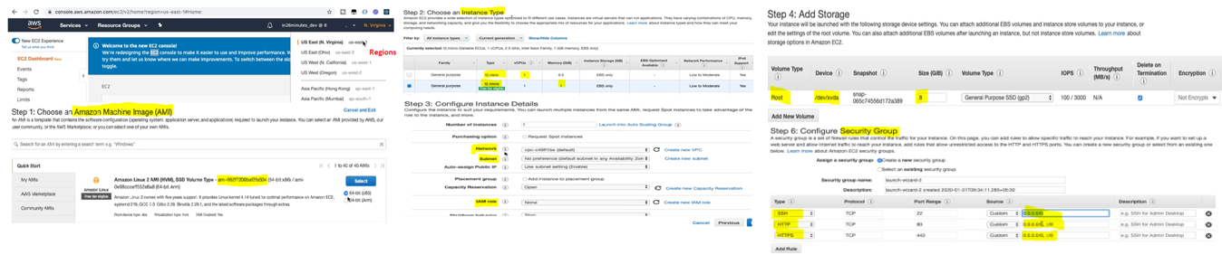

Create EC2 instance using Terraform?
# lets say we will create a http server which can allow access to port 22 for ssh , 80 for http , for the CIDR of any specified range of IP addresses. ( when CIDR value is 0.0.0.0/0 allow access from any system everywhere.)

How to create security group in terraform?
vi main.tf

Provider “aws”{
Region = “us-east-1”
Version = “~>2.46”
}

Resource “aws_security_group” “http_server_sg”{
name = “http_server_sg”
vpc_id = “vpc-c49ff1be”
ingress { ------------ ingress will allow traffic on specified port (to enter the data from outside)
from the range of server in CIDR.
So, to allow request from outside, you need to configure a from port
and a to port. The from port and to port is equal.
from_port = 80
to_port = 80
protocol = “tcp”
cidr_blocks = [“0.0.0.0/0”] -------------- you can allow traffic from the IP address ranges
}
Ingress {
from_port = 22
to_port = 22
protocol = “tcp”
cidr_blocks = [“0.0.0.0/0”]
}
egress { ------------------ egress refers to the flow of data moving out of a private network into
the public internet or another external network.
from_port = 0
to_port = 0
protocol = “tcp”
cidr_blocks = [“0.0.0.0/0”]
}
Tag = {
name = “http_server_sg”
}
}

vi output.tf

output “aws_security_group_http_servers_detail”{
value = aws_security_group.http_server_sg
}

Now when we will execute terraform apply command, the security group will be created.

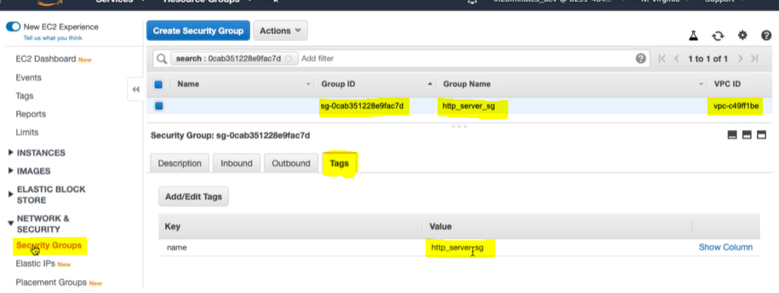

How to create a key value pair for EC2 in AWS?
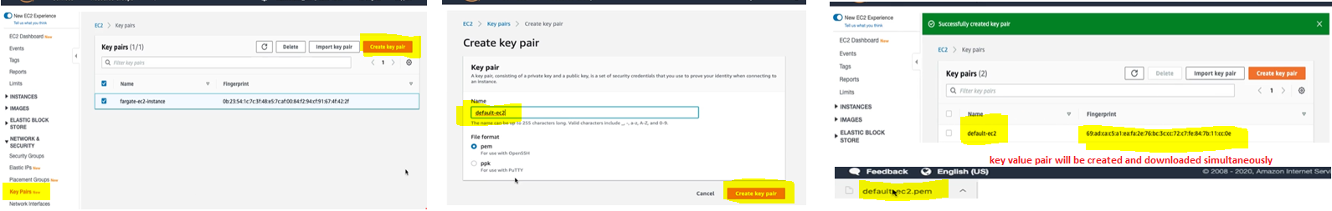

How to create the EC2 instance in Terraform?
vi main.tf

Provider “aws”{
Region = “us-east-1”
Version = “~>2.46”
}

Resource “aws_security_group” “http_server_sg”{
name = “http_server_sg”
vpc_id = “vpc-c49ff1be”
ingress { ------------ ingress will allow traffic on specified port (to enter the data from outside)
from the range of server in CIDR.
So, to allow request from outside, you need to configure a from port
and a to port. The from port and to port is equal.
from_port = 80
to_port = 80
protocol = “tcp”
cidr_blocks = [“0.0.0.0/0”] -------------- you can allow traffic from the IP address ranges
}
Ingress {
from_port = 22
to_port = 22
protocol = “tcp”
cidr_blocks = [“0.0.0.0/0”]
}
egress { ------------------ egress refers to the flow of data moving out of a private network into
the public internet or another external network.
from_port = 0
to_port = 0
protocol = “tcp”
cidr_blocks = [“0.0.0.0/0”]
}
Tag = {
name = “http_server_sg”
}
}
resource “aws_instance” “http_server”{
ami = “ami-062f7200baf2fa5044” ------------------- get this from aws ec2 console
key_name = “default-ec2” ------------------- create on aws console before use
instance_type = “t2.micro” ------------------- get it from aws ec2 console
vpc_security_group_ids = [aws_security_group.http_server_sg.id]
subnet_id = “subnet-3f7b2563” ------------------- look into the aws security console
}

When we execute terraform apply it will get the below details and create an EC2 instance.
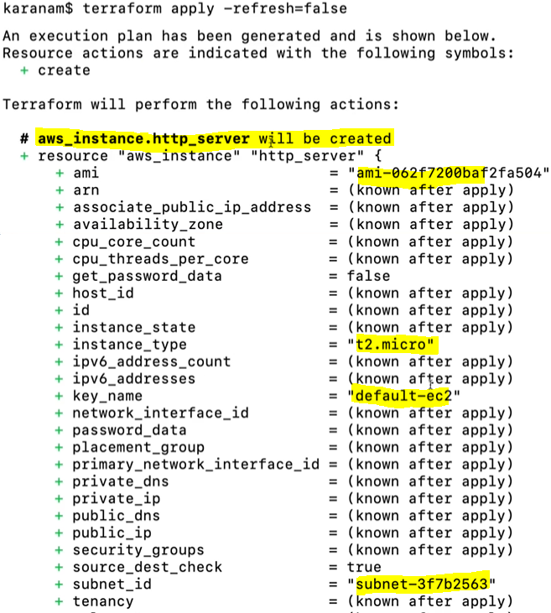
Now to capture the EC2 instance details in the output we can use below in the output terraform file.
vi output.tf

output “aws_security_group_http_servers_detail”{ ----------- security detail will show
value = aws_security_group.http_server_sg
}
output “aws_instance_http_server”{ ------------ Ec2 instance detail will show
value = aws_instance.http_server
}

How to connect to the EC2 instance created above?
To connect EC2 instance we need connection and provisioner.

vi main.tf

variable “aws_key_pair” {
default = “~/aws/my_aws_keys/default-ec2.pem” --------------- key value pair file for EC2
}
Provider “aws”{
Region = “us-east-1”
Version = “~>2.46”
}

### below use to create security group and enable port to communicate

Resource “aws_security_group” “http_server_sg”{
name = “http_server_sg”
vpc_id = “vpc-c49ff1be”
ingress { ------------ ingress will allow traffic on specified port (to enter the data from outside)
from the range of server in CIDR.
So, to allow request from outside, you need to configure a from port
and a to port. The from port and to port is equal.
from_port = 80
to_port = 80
protocol = “tcp”
cidr_blocks = [“0.0.0.0/0”] -------------- you can allow traffic from the IP address ranges
}
Ingress {
from_port = 22
to_port = 22
protocol = “tcp”
cidr_blocks = [“0.0.0.0/0”]
}
egress { ------------------ egress refers to the flow of data moving out of a private network into
the public internet or another external network.
from_port = 0
to_port = 0
protocol = “tcp”
cidr_blocks = [“0.0.0.0/0”]
}
Tag = {
name = “http_server_sg”
}
}

#### below use to create Ec2 instance and enable http server

resource “aws_instance” “http_server”{
ami = “ami-062f7200baf2fa5044” ------------------- get this from aws ec2 console
key_name = “default-ec2” ------------------- create on aws console before use
instance_type = “t2.micro” ------------------- get it from aws ec2 console
vpc_security_group_ids = [aws_security_group.http_server_sg.id]
subnet_id = “subnet-3f7b2563” ------------------- look into the aws security console

connection {
type = “ssh”
host = self.public_ip
user = “ec2-user”
private_key = file(var.aws_key_pair)
}
Provisioner “remote-exec” {
Inline = [
“sudo yum install httpd -y”
“sudo service httpd start”
“echo welcome to server at ${self.public_dns} | sudo tee /var/www/htmp/index.html”
]
}
}

vi outputs.tf
output “aws_security_group_http_servers_detail”{ ----------- security detail will show
value = aws_security_group.http_server_sg
}
output “aws_instance_http_server”{ ------------ Ec2 instance detail will show
value = aws_instance.http_server
}
output “http_server_public_ip”{
value = aws_instance.http_server.public_dns
}

Now first we need to execute terraform destroy ----------- as the resource is already exist terraform will not do any modification to the EC2.
Execute terraform apply ------ it will create the EC2 instance again with all our change and connect to EC2

Using the public DNs in browser we will connect the server and get the output message

why you'd want to create immutable servers?
let's say you are using infrastructure as code to provision servers. And you write script to do a tweak the configuration for server. If the script files, then it will be difficult to reconfigure the original server.
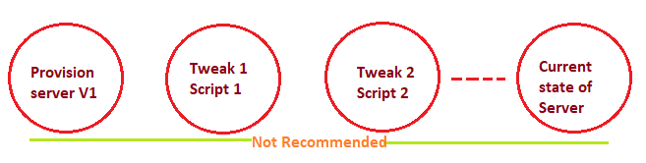
To overcome from this, we can create a new server with the V2 of the configuration. Once the new server is up and running, you can actually go ahead and remove the old server.
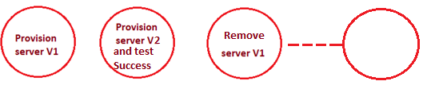
What is aws_default_vpc ?
The aws_default_vpc resource use to manage the default VPC for the specific reason in AWS.

Provider “aws”{
Region = “us-east-1”
Version = “~>2.46”
}

resource “aws_default_vpc” “my_default” {
}
Now we can use it to get the vpc detail and as per the requirement we can use it in terraform program.
Ex -->
resource “aws_security_group” “http_server_sg”{
name = “http_server_sg”
vpc_id = aws_default_vpc.my_default.id
|
|
|
}

What is data providers / data sources?
if you want to actually get data from the cloud resources, you can actually create something called data providers and use them to get the data and map it.

What is the difference between data source and variables in Terraform?
Variables are typically used to manage our configurations more flexible and easier.
Data sources are used to retrieve information from external systems or existing resources and incorporate that information into our configuration.

How to retrieve the subnets from vpc? How to use subnet-ids dynamically in terraform?
Provider “aws”{
Region = “us-east-1”
Version = “~>2.46”
}

resource “aws_default_vpc” “my_default” {
}
data “aws_subnet_ids” “my_default_subnets” {
vpc_id = aws_default_vpc.my_default.id
}

Now we can execute terraform apply -target= data. aws_subnet_ids. my_default_subnets
Go to terraform console and execute data. aws_subnet_ids. my_default_subnets we will get the vpc_id and subnet ids in a set.
To fetch particular subnet id we need to change set to list and get the particular subnet.
Tolist( data. aws_subnet_ids. my_default_subnets.ids)[0]

How to use AMI ( amazon machine image) for EC2 with data providers? How to use AMI dynamically?

data “aws_ami_ids” “aws_linux_2_latest_ids”{
owners = [“amazon”]
}

terraform apply -target=data. aws_ami_ids. aws_linux_2_latest_ids --------------- will provide all the list of ids present in AWS.

data “aws_ami” “aws_linux_2_latest”{
most_recent = true
owners = [“amazon”]
filter{
name = “name”
values = [“amzn2-ami-hvm*”]
}
filter{
name = “architecture”
values = [“x86_64”]
}
}

terraform apply -target=data. aws_ami. aws_linux_2_latest ----------------- will provide all the details of AWS latest ami.

The latest ami id will be data.aws_ami. aws_linux_2_latest.id --------- so we can use this in the code instead of hardcoding the value.

How to create terraform graph / resource graph?
Terraform graph output uses the DOT language, which is a machine-readable graph description language which originated in Graphviz.
The command terraform graph generate the output which we can paste in https://dreampuf.github.io/GraphvizOnline/ we will get the graphical view of the resource flow diagram.

How to modularize the terraform program?
Create file for variables ( ex variable.tf) , other file for data variables (ex data_variables.tf )
One main terraform program file (ex main.tf ) and lastly there should be an output file ( output.tf)

Vi variable.tf

variable “aws_key_pair” {
default = “~/aws/my_aws_keys/default-ec2.pem” ------------ key value pair file for EC2
}

Vi data_variable.tf

data “aws_subnet_ids” “my_default_subnets” {
vpc_id = aws_default_vpc.my_default.id
}

data “aws_ami” “aws_linux_2_latest”{
most_recent = true
owners = [“amazon”]
filter{
name = “name”
values = [“amzn2-ami-hvm*”]
}
filter{
name = “architecture”
values = [“x86_64”]
}
}

data “aws_ami_ids” “aws_linux_2_latest_ids”{
owners = [“amazon”]
}

vi main.tf

Provider “aws”{
Region = “us-east-1”
Version = “~>2.46”
}
resource “aws_default_vpc” “my_default” {
}

Resource “aws_security_group” “http_server_sg”{
name = “http_server_sg”
#vpc_id = “vpc-c49ff1be”
vpc_id = aws_default_vpc.my_default.id
ingress { ------------ ingress will allow traffic on specified port (to enter the data from outside)
from the range of server in CIDR.
So, to allow request from outside, you need to configure a from port
and a to port. The from port and to port is equal.
from_port = 80
to_port = 80
protocol = “tcp”
cidr_blocks = [“0.0.0.0/0”] -------------- you can allow traffic from the IP address ranges
}
Ingress {
from_port = 22
to_port = 22
protocol = “tcp”
cidr_blocks = [“0.0.0.0/0”]
}
egress { ------------------ egress refers to the flow of data moving out of a private network into the public internet or another external network.
from_port = 0
to_port = 0
protocol = “tcp”
cidr_blocks = [“0.0.0.0/0”]
}
Tag = {
name = “http_server_sg”
}
}
resource “aws_instance” “http_server”{
#ami = “ami-062f7200baf2fa5044” ------------------- get this from aws ec2 console
ami = data.aws_ami.aws_linux_2_latest
key_name = “default-ec2” ------------------- create on aws console before use
instance_type = “t2.micro” ------------------- get it from aws ec2 console
vpc_security_group_ids = [aws_security_group.http_server_sg.id]
#subnet_id = “subnet-3f7b2563” ---------------- look into the aws security console
subnet_id = tolist(data. aws_subnet_ids. my_default_subnets.ids)[0])
connection {
type = “ssh”
host = self.public_ip
user = “ec2-user”
private_key = file(var.aws_key_pair)
}
Provisioner “remote-exec” {
Inline = [
“sudo yum install httpd -y”
“sudo service httpd start”
“echo welcome to server at ${self.public_dns} | sudo tee /var/www/htmp/index.html”
]
}
}

vi outputs.tf
output “aws_security_group_http_servers_detail”{ ----------- security detail will show
value = aws_security_group.http_server_sg
}
output “aws_instance_http_server”{ ------------ Ec2 instance detail will show
value = aws_instance.http_server
}
output “http_server_public_ip”{
value = aws_instance.http_server.public_dns
}

Now we can run terraform apply

How to get all the subnet ids in terraform?
for_each = toset(data. aws_subnet_ids. my_default_subnets.ids)

How to create multiple EC2 instance with load balancer in terraform?

Vi variable.tf

variable “aws_key_pair” {
default = “~/aws/my_aws_keys/default-ec2.pem” ------------ key value pair file for EC2
}

Vi data_variable.tf

data “aws_subnet_ids” “my_default_subnets” {
vpc_id = aws_default_vpc.my_default.id
}

data “aws_ami” “aws_linux_2_latest”{
most_recent = true
owners = [“amazon”]
filter{
name = “name”
values = [“amzn2-ami-hvm*”]
}
filter{
name = “architecture”
values = [“x86_64”]
}
}

data “aws_ami_ids” “aws_linux_2_latest_ids”{
owners = [“amazon”]
}

vi main.tf

Provider “aws”{
Region = “us-east-1”
Version = “~>2.46”
}
resource “aws_default_vpc” “my_default” {
}

resource “aws_security_group” “http_server_sg”{
name = “http_server_sg”
#vpc_id = “vpc-c49ff1be”
vpc_id = aws_default_vpc.my_default.id
ingress { ------------ ingress will allow traffic on specified port (to enter the data from outside) from the range of server in CIDR. So, to allow request from outside, you need to configure a from port and a to port. The from port and to port is equal.
from_port = 80
to_port = 80
protocol = “tcp”
cidr_blocks = [“0.0.0.0/0”] -------------- you can allow traffic from the IP address ranges
}
ingress {
from_port = 22
to_port = 22
protocol = “tcp”
cidr_blocks = [“0.0.0.0/0”]
}
egress { ------------------ egress refers to the flow of data moving out of a private network into the public internet or another external network.
from_port = 0
to_port = 0
protocol = “tcp”
cidr_blocks = [“0.0.0.0/0”]
}
Tag = {
name = “http_server_sg”
}
}
resource “aws_instance” “http_servers”{
#ami = “ami-062f7200baf2fa5044” ------------------- get this from aws ec2 console
ami = data.aws_ami.aws_linux_2_latest
key_name = “default-ec2” ------------------- create on aws console before use
instance_type = “t2.micro” ------------------- get it from aws ec2 console
vpc_security_group_ids = [aws_security_group.http_server_sg.id]

# To get multiple EC2 we need multiple ips so need to loop subnet ids
for_each = data. aws_subnet_ids. my_default_subnets.ids
subnet_id = each.value
tag = {
name = “http_servers_${ each.value}”
}
connection {
type = “ssh”
host = self.public_ip
user = “ec2-user”
private_key = file(var.aws_key_pair)
}
Provisioner “remote-exec” {
Inline = [
“sudo yum install httpd -y”
“sudo service httpd start”
“echo welcome to server at ${self.public_dns} | sudo tee /var/www/htmp/index.html”
]
}
}

vi outputs.tf
output “aws_security_group_http_servers_detail”{ ----------- security detail will show
value = aws_security_group.http_server_sg
}
output “aws_instance_http_servers_public_dns”{ ------------ Ec2 instance detail will show
value = aws_instance.http_servers
}
Now execute terraform apply -target= data. aws_subnet_ids. my_default_subnets
Then execute terraform apply it will create multiple EC2 instance

Let’s create the load balancer security group and load balancer resource to load balance EC2 instances.

Vi variable.tf

variable “aws_key_pair” {
default = “~/aws/my_aws_keys/default-ec2.pem” ------------ key value pair file for EC2
}

Vi data_variable.tf

data “aws_subnet_ids” “my_default_subnets” {
vpc_id = aws_default_vpc.my_default.id
}

data “aws_ami” “aws_linux_2_latest”{
most_recent = true
owners = [“amazon”]
filter{
name = “name”
values = [“amzn2-ami-hvm*”]
}
filter{
name = “architecture”
values = [“x86_64”]
}
}

data “aws_ami_ids” “aws_linux_2_latest_ids”{
owners = [“amazon”]
}

vi main.tf

Provider “aws”{
Region = “us-east-1”
Version = “~>2.46”
}
resource “aws_default_vpc” “my_default” {
}

resource “aws_security_group” “http_server_sg”{
name = “http_server_sg”
#vpc_id = “vpc-c49ff1be”
vpc_id = aws_default_vpc.my_default.id
ingress { ------------ ingress will allow traffic on specified port (to enter the data from outside) from the range of server in CIDR. So, to allow request from outside, you need to configure a from port and a to port. The from port and to port is equal.
from_port = 80
to_port = 80
protocol = “tcp”
cidr_blocks = [“0.0.0.0/0”] -------------- you can allow traffic from the IP address ranges
}
ingress {
from_port = 22
to_port = 22
protocol = “tcp”
cidr_blocks = [“0.0.0.0/0”]
}
egress { ------------------ egress refers to the flow of data moving out of a private network into the public internet or another external network.
from_port = 0
to_port = 0
protocol = “tcp”
cidr_blocks = [“0.0.0.0/0”]
}
Tag = {
name = “http_server_sg”
}
}

resource “aws_security_group” “elb_sg”{ #-------- elb_sg is the load balancer security group
name = “elb_sg”
vpc_id = aws_default_vpc.my_default.id
ingress {
from_port = 80
to_port = 80
protocol = “tcp”
cidr_blocks = [“0.0.0.0/0”]
}
egress {
from_port = 0
to_port = 0
protocol = “tcp”
cidr_blocks = [“0.0.0.0/0”]
}
}

resource “aws_elb” “elb”{
name = ”elb”
subnet = data.aws_subnet_ids.default_subnets.ids
security_group = [aws_security_group.elb_sg.id]
instances = values(aws_instance_http_servers).*.id

listener { -------------------- listener is basically which port on the load balancer should redirect to which port on the EC2 instances.

instance_port = 80 ------------ ec2 instance port
instance_protocol = “http”

lb_port = 80
lb_protocol = “http”
}
}

resource “aws_instance” “http_servers”{
#ami = “ami-062f7200baf2fa5044” ------------------- get this from aws ec2 console
ami = data.aws_ami.aws_linux_2_latest
key_name = “default-ec2” ------------------- create on aws console before use
instance_type = “t2.micro” ------------------- get it from aws ec2 console
vpc_security_group_ids = [aws_security_group.http_server_sg.id]

# To get multiple EC2 we need multiple ips so need to loop subnet ids
for_each = data. aws_subnet_ids. my_default_subnets.ids
subnet_id = each.value
tag = {
name = “http_servers_${ each.value}”
}
connection {
type = “ssh”
host = self.public_ip
user = “ec2-user”
private_key = file(var.aws_key_pair)
}
Provisioner “remote-exec” {
Inline = [
“sudo yum install httpd -y”
“sudo service httpd start”
“echo welcome to server at ${self.public_dns} | sudo tee /var/www/htmp/index.html”
]
}
}

vi outputs.tf
output “aws_security_group_http_servers_detail”{ ----------- security detail will show
value = aws_security_group.http_server_sg
}
output “aws_instance_http_servers_public_dns”{ ------------ Ec2 instance detail will show
value = aws_instance.http_servers
}
output “aws_instance_http_servers_public_dns_ids”{ ------------ Ec2 instance ids will show
value = values(aws_instance.http_servers).*.id
}
output “elb_public_dns”{
value = aws_elb.elb
}

Now execute terraform apply it will create the load balancer security group and load balancer

How to create S3 bucket for a backend project?
In this terraform code we will create a S3 bucket. So that we can store all the states ( .st files ) and user states. To store these states user may use different keys as per the requirement.
Locking is very important for S3 bucket, as we have multiple users executing at the same time and we don’t want to corrupt the state. We will use DynamoDB, DynamoDB support locks. With the help of lock the user we can create lock update the state ( .st file) and once the change updated release the lock.
This will ensure that there will be only one user at any point in time who's trying to update state
and who's trying to execute anything on your environment.
In S3 bucket you can set encryption to be true and your state is completely encrypted.

export AWS_ACCESS_KEY_ID=AKHMNEFUHWOBVER
export AWS_SECRET_KEY_ID=NHTVIKHKGOLERMPLERSDRTWITLJLWPLDSA

provider "aws" {
region = "us-east-1"
version = "~> 2.46"
access_key = “AWS_ACCESS_KEY_ID”
secret_key = “AWS_SECRET_KEY_ID”

}
//S3 bucket
resource "aws_s3_bucket" "enterprise_backend_state" { -------- the resource use to create S3 bucket
bucket = "dev-applications-backend-state-in28minutes-abc"
lifecycle { ------------------ life cycle will enable us to prevent deletion of this specific bucket.

prevent_destroy = true
}
versioning { -------------------------- to store multiple versions of state.
enabled = true
}
server_side_encryption_configuration { ------ store state information in an encrypted way.
rule {
apply_server_side_encryption_by_default {
sse_algorithm = "AES256" ---------------- server side encryption algorithm using AES 256, 256 bit AES.
}
}
}

}

resource "aws_s3_bucket_versioning" "versioning_example" {
bucket = aws_s3_bucket.enterprise_backend_state.id
versioning_configuration {
status = "Enabled"
}
}

resource "aws_s3_bucket_server_side_encryption_configuration" "example" {
bucket = aws_s3_bucket.enterprise_backend_state.bucket

rule {
apply_server_side_encryption_by_default {
sse_algorithm = "AES256"
}
}
}

//Locking - Dynamo DB

resource "aws_dynamodb_table" "enterprise_backend_lock" {
name = "dev_application_locks"
billing_mode = "PAY_PER_REQUEST"
hash_key = "LockID"
attribute {
name = "LockID"
type = "S"
}

}

How to store a terraform project in S3 bucket?
In this we are keeping the users project in the S3 bucket.

vi /terraform/backup/07-backend-state/users/main.tf

variable app_name {
default = “07-backend-state”
}
variable env_name {
default = “dev”
}
variable proj_name {
default = “users”
}

terraform {
backend "s3" {
bucket = "dev-applications-backend-state-in28minutes-abc" ---------- the S3 bucket created above
#key = "07-backend-state-users-dev"
Key = “${app_name}-${proj_name}-${env_name}”
#key = "dev/07-backend-state/users/backend-state" -------- also we can create hierarchical way
region = "us-east-1"
dynamodb_table = "dev_application_locks" -------- same name of table present in S3 bucket
encrypt = true
}
}

provider "aws" {
region = "us-east-1"
version = "~> 2.46"
}

resource "aws_iam_user" "my_iam_user" {
name = "${terraform.workspace}_my_iam_user_abc"
}

Now if we execute terraform init we will get the state file in S3 bucket

How to get the current workspace name in terraform?
Terraform workspace show
How to create a new workspace and switch into that?
Terraform workspace new the_ws_name

Ex Terraform workspace new prod -------------------execute S3 bucket terraform code to create S3 bucket and then if we execute the command in terraform console it will create a prod folder in S3 bucket.

How to switch to another workspace?
Terraform workspace select the_ws_name
Ex terraform workspace select default

How to list all the workspaces?
Terraform workspace list

How to create the module in terraform? How to create directory structure and modularize terraform code?
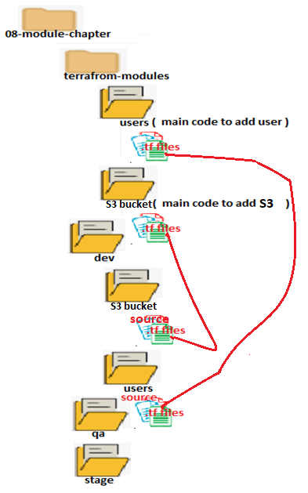
Original code will be written under users, S3_bucket folders, which is present in terraform-modules.
So under terraform-modules all our modules can be stored.
Here in the dev and the QA is where we would control the execution of those modules.

Let’s create the main source code in users folder which is under terraform-modules folder.

Vi main.tf

variable "environment" {
default = "default"
}

provider "aws" {
region = "us-east-1"
version = "~> 2.46"
}

locals { --------------it is same as variable but it is a static variable, value of the variable could not change
iam_user_extension = "my_iam_user_abc"
}

resource "aws_iam_user" "my_iam_user" {
name = "${local.iam_user_extension}_${var.environment}"
}

Vi output.tf

output "my_iam_user_complete_details" {
value = aws_iam_user.my_iam_user
}

Now we need to source this module to dev. So write a terraform code in users folder which is under dev.

Vi main.tf

module "user_module" {
source = "../../terraform-modules/users"
environment = "dev"
}

Now go to dev/users folder and run terraform init in the console. And then execute terraform apply to create the users.

Cloud devops ( Ansible )
======================
Ansible config file for aws cloud?
All the configuration of Ansible will be present in ansible configuration file and the particular file called ansible.cfg.
For Aws the ansible.cfg file should have below details.

vi ansible.cfg

[defaults]
inventory=./ansible_hosts # In ansible_hosts contains the servers list to which we want to talk to.
remote_user=ec2-user # ec2-user is the user name which we use to perform ssh
private_key_file=~/aws/aws_keys/default-ec2.pem # the private key file use to access the servers
host_key_checking=False
retry_files_enabled=False
interpreter_python=auto_silent

How to identify the list of tasks (What the tasks will do) when you have multiple playbooks imported to a single playbook?
vi multi-playbooks.yaml

- Import_playbook: the-ping.yaml
- Import_playbook: ex-shell.yaml
- Import_playbook: install-http.yaml

Now to know what the task will do when we execute multi-playbooks.yaml we can use below command

Ansible-playbook multi-playbooks.yaml --list-tasks

How to identify which play will execute in which host (What the tasks will do) when you have multiple playbooks imported to a single playbook?

Ansible-playbook multi-playbooks.yaml --list-hosts

How to create dynamic inventory for Aws Ec2 instance in Ansible?

Pre requisite is to install Boto3 using pip

Then create a file aws-ec2-inv.yaml in inventory folder with below content

plugin: aws_ec2
region:
- us-east-1
Keyed_groups:
- prefix: tag
Key: ‘tags’ # it will capture the tag of EC2 instance from aws and group the servers
- prefix: aws_region
Key: ‘tags.Environment’ # here Environment is the key name in AWS EC2 tag
separator: ‘ ’ # Give the value of aws ec2 tag key and group the servers as per value ( advisable)

Now in ansible.cfg file mention the inventory path.

vi ansible.cfg

[defaults]
inventory=inventory/ aws-ec2-inv.yaml
remote_user=ec2-user
private_key_file=~/aws/aws_keys/default-ec2.pem

How to create EC2 instance using Ansible?
Vi create-ec2-ins.yaml

---
- hosts: localhost
tasks:
- ec2:
key_name: default-ec2 # create a key in AWS and use it here
instance_type: t2.micro
image: ami-062f7200baf2fa504
region: us-east-1
count: 1
vpc_subnet_id: subnet-75cb9912
assign_public_ip: yes
group:
instance_tags: {type: http , Environment: QA}
wait: yes
register: ec2_output
- debug: var=ec2_output

Cloud Devops ( k8)
===============================
Aws EKS needs two step process
- Setup the cluster
- Create the policy binding.

https://medium.com/@tech_18484/step-by-step-guide-creating-an-eks-cluster-with-terraform-resources-iam-roles-for-service-df1c5e389811

